TBOT II Robotic Arms Update

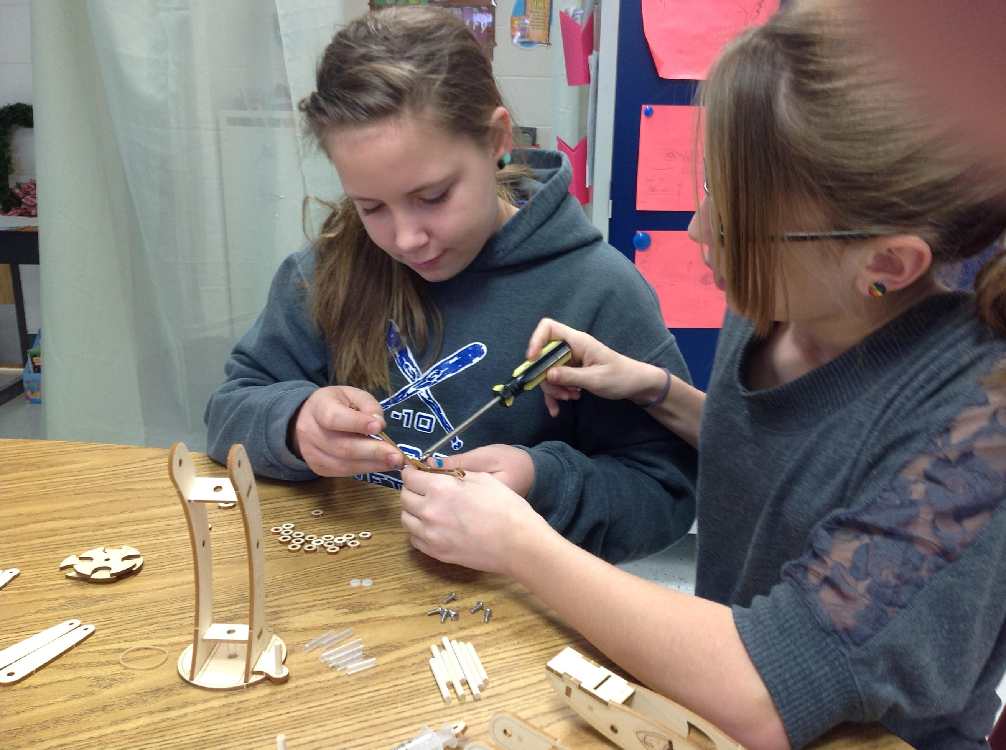
Students in the Quest program have been working for three weeks to complete their hydraulic robot arms. It has been interesting, as the students were very inquisitive about how the arms would work. At first, they could not comprehend how they would combine wood and water to create a robotic force. The final product astounded them, as they realized how the hydraulic system worked. Along with learning about hydraulic forces, the students have also learned to carefully follow very detailed directions and work in small groups to complete an awesome product. Some of the groups of students will be using.
