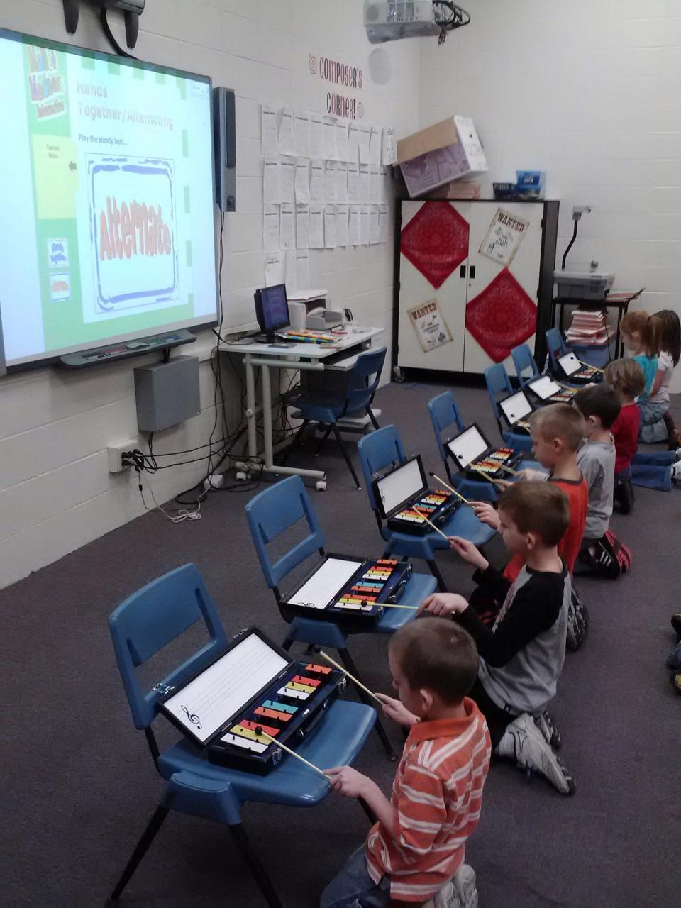
The grant money I received was used to purchase the Mallet Madness and Mallet Madness Strikes again interactive program for the SMARTboard. The programs contain a collection of units for mallet instruments and drums to use in the music room. Specifically it concentrates on rhythm skills and music and literature connections. By tying in children’s literature to the music classroom it is not only another chance to get students reading, but it gives them another method of approaching the book. Each volume contains rhythmic and melodic activities for ten different stories to help encourage the students to keep reading outside the boundaries of their homeroom.
Each volume also emphasizes rhythm and technique for playing mallet instruments. These skills are great for reinforcing hand eye coordination, counting, and problem solving- all lifelong skills that we try to promote in our buildings. The first lesson we did using this unit was in second grade. They were just being introduced to holding the mallets the correct way, reading a rhythm, and playing it with the correct hand pattern. Given the opportunity to explore what they though the definitions for playing hands together and alternating were, they were able to use those skills to work on mastering a rhythm to perform. We ended our first lesson by playing a pattern called crazy eighths where you started off playing for one beat and resting for seven. The pattern continues until students are all 8 beats which requires them to count and read along with the music.
These resources are a great addition to the K-5 general music curriculum to use with our limited amount of mallet instruments. My hope is that in the future through other grants we will be able to increase our inventory of mallet instruments to allow for more students to be performing at a time. These instruments and materials help support the Orff Schulwerk method of music education based on following quote: "Tell me, I forget, show me, I remember, involve me, I understand."

